FEDERATION OF NORTHERN ONTARIO MUNICIPALITIES
MINUTES
Sunday, January 18th, 2026

Present
D. Plourde, President
S. Hollingsworth, Director
A. MacNevin, Director
M. Horsfield, 1st Vice President
L. Watson, 2nd Vice President

Zoom
D. Whalen, Past President
L. Carleton, Director
L. Feldman, Director

R. Carrier, Director

Regrets
T. Kelly, Director
P. Lefebvre, Director

M. Signoretti, Director

Guests

None

Staff
M. Bain, Executive Director

1.0 Welcome and President's Report
President Dave Plourde shared that we remain busy with the multi-laning of Highway 11 & 17. Also, he attended the Northland Rail Car unveiling in Toronto with the Premier. Taking the opportunity to help respond to media inquiries in French. We have been busy preparing for the ROMA Conference.
.
R. Carrier moved, SECONDED by M. Horsfield, that the President’s Report be received
MOTION CARRIED.

ADDITIONS TO/APPROVAL OF AGENDA

A. MacNevin moved, SECONDED by S. Hollingsworth, that the Agenda be approved with additions
MOTION CARRIED.

3.0 Timed Delegations
None

4.0 ADOPTION OF MINUTES OF THE December 4, 2025, BOARD MEETING

L. Watson moved, SECONDED by L. Carleton, that the Minutes be accepted as presented.
MOTION CARRIED.

5.0 BUSINESS ARISING FROM THE MINUTES

5.1 M. Bain provided the Board with an update on the proposed “FONOM Day” at Queen’s Park, including a potential partnership with KWM. He outlined KWM’s role and the event's structure. M. Bain recommended that the event costs be funded from existing investments. Following a discussion, the Board requested a formal resolution to authorize KWM’s involvement and the use of investment funds to cover event-related costs.

D. Whalen moved, seconded by M. Horsfield, that Mac Bain be authorized to enter into and sign an agreement with KWM related to the organization of FONOM Day at Queen’s Park; and that one of our investments held with the Caisse Populaire be redeemed at maturity, with the proceeds used to cover the costs associated with this event.
MOTION CARRIED.

5.2 M. Bain noted that he spoke with Stacey Fiddle from the Labour Market Group, and her Northern Colleagues are reviewing the draft survey questions and working on a survey that we will send out to our membership. The results will aid FONOM in its future discussions with the Minister of Colleges, Universities, Research Excellence and Security. FONOM wants to help our members with the chronic human resources shortages they are experiencing.

5.0 BUSINESS ARISING FROM THE MINUTES - continued

5.3 D. Plourde, D. Whalen and M. Bain shared the work that has been done on the multiple laning of Highway 11 & 17. Discussion continues with the Province, the Federal Government, and industries that use our Highways. Since December, we have received over 40 municipal resolutions, along with support from industry and associations. A lengthy discussion took place, and Mac was asked to send a reminder email requesting additional support.

6.4 M. Bain, provide a brief update on the Annual FONOM Conference to the Board. He noted that the Timmins team was doing a great job and would share details with the Board between meetings.

6.0 NEW BUSINESS

6.1 Resolution Received – Site Readiness Funding
Municipality of Magnetawan and four other Municipalities

FONOM will write a letter to the Minister, reminding them that all Provincial Projects and Grants
should be structured to allow all Municipalities to apply.

6.2 Resolution Received – Conservation Authorities mergers
Municipality of Magnetawan

L. Watson moved, SECONDED by S. Hollingsworth, that a letter be sent to Minister McCarthy regarding the planned merger of the Northern Conservation Authorities. The letter will highlight Northern Ontario's unique qualities and request additional consultation.
MOTION CARRIED.

6.3 Resolution Received – 2026 Election conflict with Provincial Emergency Exercises
Township of Tarbutt

The Board asked M. Bain to investigate the proposed Exercises and communicate to the Minister the hardship this would have on Northern Municipalities.

6.4 Letter and Resolution Received – OCIF funding level
Town of Cobalt

The Board asked M. Bain to investigate the issue and communicate with Minister Kinga Surma (Ministry of Infrastructure). He is to explain the importance of the annual OCIP funding, which addresses Northern Municipalities' infrastructure deficit.

6.5 Resolution Received – Support for Steel and Lumber Sectors
Township of Nairn and Hyman and one other Municipality

6.6 Resolution Received – Temiskaming Municipal Association
Temiskaming Municipal Association

6.7 Resolution Received – Removing HST/GST from New Homes to Support Housing Affordability Town of Kirkland Lake

7.0 Correspondence/Information Items

- MacNevin moved, seconded by L. Carleton, that all correspondence items be received for informational purposes.

7.1 Letter Received – Support for the Forestry Industry
7.2 Resolution Received – Aerial Spraying of Glyphosate
7.3 Resolution Received – NORDS Pilot Program
7.4 Resolution Received – Accessible and Effective Alcohol Container Return System
7.5 Media Release – Calls for Continued Provincial Partnership to Secure the Future of
7.6 Resolution Received – Upholding Women's Rights Leadership & Environmental Health in the Implementation of Ontario Bill 5
7.7 Media Release – since December Board Meeting
7.8 Resolution Received – National-Building Improvements to Hwy 11,17.
7.9 Resolution Received - Swim to Survive Training
7.10 Thank you, card, received – Mac and Debbie Bain
MOTION CARRIED.

8.0 ADMINISTRATIVE MATTERS
8.1 L. Watson moved, seconded by M. Horsfield, that the Board receive the list of
Expenditures (Attached Page 7) for November 25, 2025 – January 9, 2026
MOTION CARRIED.

8.2 S. Hollingsworth moved, seconded by D. Whalen, that the Board receive the Financial Report (Attached Page 8) ending January 9, 2026
MOTION CARRIED.

8.3 M. Bain updated the Board on the Delegation FONOM has made during the ROMA Conference.

8.4 M. Bain asked the Board what they would like him to discuss with the FedNor Team if they would have an appetite to continue funding the Sustainable Northern Ontario Economic Development program. The Board asked that Mac have these discussions with FedNor.

8.5 M. Bain updated the Board on a funding assistance email that the NOSM sent to Lynn Watson. A discussion among the Board followed, during which the history was revisited, and the lack of communication with FONOM and our membership was discussed.
The Board asked Mac to have a direct and candid discussion with the University President regarding the matter.

8.6 M. Bain shared a news story regarding the loss of the Greater Sudbury laboratory this spring.
Following a Board discussion.
FONOM will write to Minister Jones, asking that the health of Northern Ontario citizens not be put at risk by this closure. That the Province ensure that measures are put in place to maintain essential laboratory processing capacity in Northern Ontario.

8.0 ADMINISTRATIVE MATTERS - continued

8.7 M. Bain, shared with those Board members who do not sit on District Health Units, that the Province again capped the funding amount at 1% for mandated programs. As this is a Provincial cap, FONOM will continue to monitor the funding impacts.

9.0 REGIONAL REPORTS

District of Temiskaming
D. Whalen noted that now that winter has hit the region, talk has turned to the Highway. Danny said he planned to attend the Highway Rally in Cochrane and would report back in March.

District of Parry Sound
L. Carleton shared that she has been meeting with the Fire Marshal's Office to discuss Certification. One of their questions is why they need to be qualified on an Aerial Truck when the municipality does not have a three-storey building. Lynda mentioned that the Township is asking the Fire Marshal’s Office to consider extending the certification deadline for its volunteers. She noted that the area Planning Boards are busy, with a high number of objections to most applications. Lastly, she remarked that the Library Budget has increased sharply due to the cost of Postage for interlibrary loans.

District of Sudbury
R. Carrier noted that the Health Unit levy increase is concerning and that the Province has only increased its payment by 1%. Renée also noted that the snow has led to numerous closures in her area, affecting people and businesses.

City of North Bay
M. Horsfield shared that the City’s Clerk is seeking direction from the Province on one of the School Board elections this fall. The Minister of Education has assumed control of the Near North District School Board, and the Clerk is seeking guidance on how to prepare for the vote.

District of Manitoulin
A. MacNevin reported that the Manitoulin Island Municipal Association has not met since the last meeting, but they will be meeting on January 21st, and that he will report out after that.

District of Algoma
L. Watson reported that the Algoma Municipal District Association meeting is scheduled for April. As Maggie noted, many of the region's clerks remain uncertain about how to proceed with school board elections. Lynn added that his local health unit's budget increase is considerable. Finally, he expressed concern about the impacts of frequent winter highway closures, emphasizing not only their frequency but also that communities can be isolated for days.

District of Cochrane
D. Plourde shared that he is busy working with KapPaper and noted that members of the Federal Government will be touring the facility shortly.

9.0 REGIONAL REPORTS – continued

City of Sault Ste Marie
S. Hollingworth shared that the City will welcome Naomi Thibault as the new Fire Chief in a few weeks. Sandra noted that the City of Sault Ste. Marie is investing over $56 million to upgrade its 40-year-old wastewater treatment plant, with significant funding support secured for the project. She also discussed the Vacant Home Tax (VHT) program, which assesses a 4% tax on the assessed value. Lastly, Sandra shared that the community is grieving the loss of an infant and a young child.

District of Nipissing – No Report provided
City of Timmins – No Report provided
City of Greater Sudbury – No Report provided

10.0 OTHER BUSINESS

11:0 IN CAMERA - none

12.0 NEXT MEETING, Friday, March 20th, 2026, in Kirkland Lake.

13.0 ADJOURNMENT – A. MacNevin moved, seconded by L. Watson, that the Board meeting be
adjourned at 1:23 pm.

ADOPTION OF MINUTES OF January 18th, 2026
L. Watson moved, SECONDED by T. Kelly, that the Minutes be accepted as presented on Friday, March 20th, 2026.
MOTION CARRIED.
__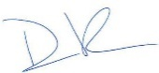_______
President Dave PlourdeJanuary

8.1
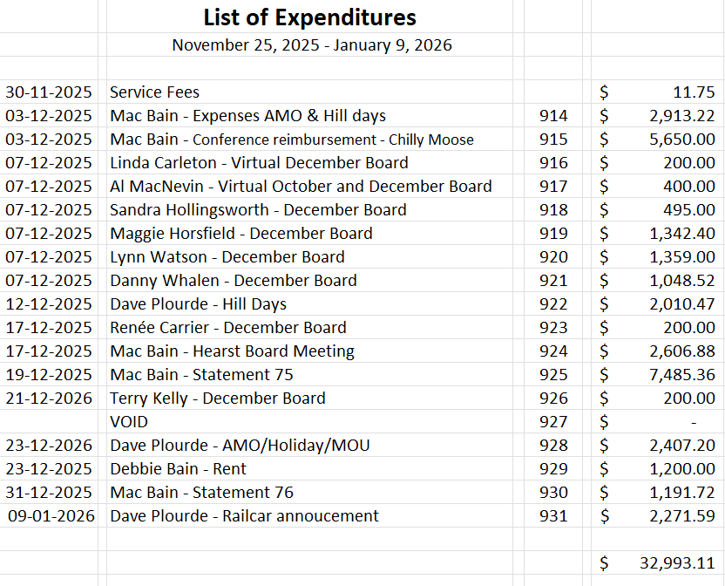

8.2

